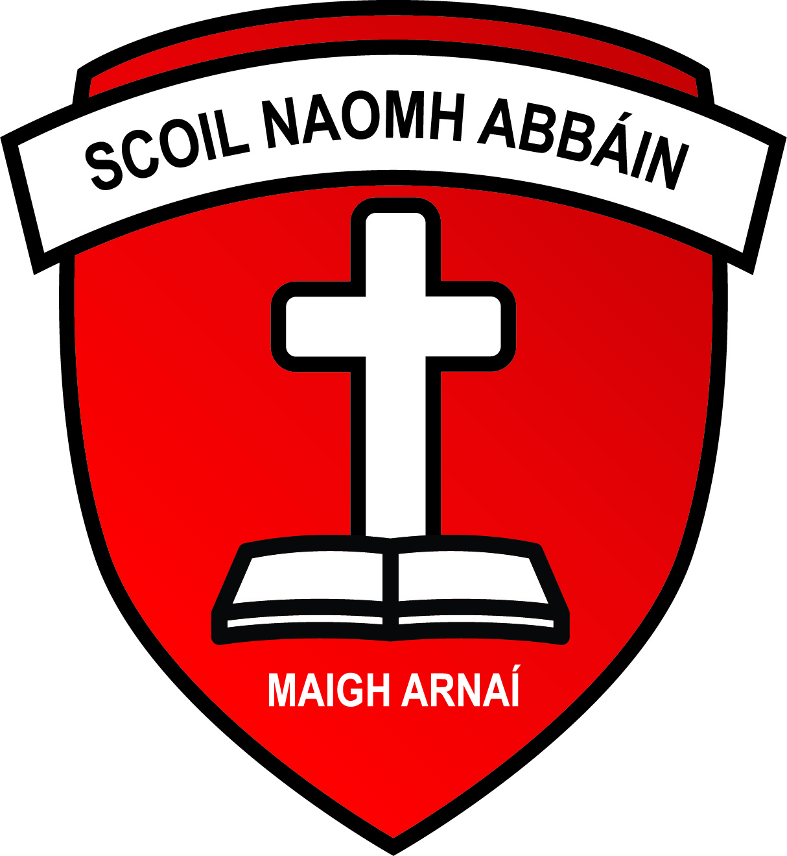
Scoil Naomh Abbain,
Adamstown, Enniscorthy, Co. Wexford.
Roll No. 17526J
Email: scoilabbain@gmail.com
www.adamstownns.ie
Phone: 053 9240694

Enrolment Form

Surname ______________ First Name ________________

Date of Birth ___________ Year of Enrolment _______

Parents/Guardians _____________________________________

Address: ____________________________________________________

Child’s PPS Number ______________

Telephone No. ________________ Alternative Contact __________

Family Doctor _______________ Dr’s Telephone No. __________

Medical & Social Information ____________________________

_____________________________________________________

Additional Information ___________________________________

_____________________________________________________

The school at present has the services of a Special Education Needs Teacher. Are you willing to allow your child avail of this support service in the school if the need should arise.
Yes _____ No _____

By enrolling my child in this school I agree that information may be passed on to relevant bodies for the education and welfare of the child.

Signature of Parent/Guardian: ____________________________ Date:_________

Scoil Naomh Abbain,
Adamstown, Enniscorthy, Co. Wexford.
Roll No. 17526J
Email: scoilabbain@gmail.com
www.adamstownns.ie
Phone: 053 9240694

Pupil Information required for Department of Education and Skills
Primary Online Database.

The Department of Education and Skills is developing an electronic database of primary school pupils called the Primary Online Database (POD) which will involve schools maintaining and returning data on pupils to the Department at individual pupil level on a live system. The database will allow the Department to evaluate progress and outcomes of pupils at primary level, to validate school enrolment returns for grant payment and teacher allocation purposes, to follow up on pupils who do not make the transfer from primary level and for statistical reporting.

The database will hold data on all primary school pupils including their PPSN, First Name, Surname, Name as per Birth Certificate, Mother’s Maiden name, Address, Date of Birth, Gender, Nationality, whether one of the pupil’s mother tongues is English or Irish, whether the pupil is in receipt of an Exemption from Irish and if so the reason for same, whether the pupil is in receipt of Learning Support and if so the type of learning support, whether the pupil is in a Mainstream or Special class. The database will record the class grouping and standard the pupil is enrolled in. The database will also contain, on an optional basis, information on the pupil’s religion and on their ethnic or cultural background.

In order to assist with the gathering of data please complete page one & two of this form in CAPITAL LETTERS and return to the school. This form will be retained by our school.

Pupil First Name: ______________________ Pupil Surname: ______________________

Class: ________

Birth Cert First Name (if different from name above) Birth Cert Surname (If different from above)

_________________________________________ ________________________________________

Pupil Address: _________________________________________________________________________

PPSN of Pupil: __________________________ Mother’s Maiden Name: _________________________

Date of Birth: ______________________________ County: __________________________________

Nationality: _______________________________ Gender : Male Female:

Is one of the pupil’s mother tongue (i.e. language spoken at home) Irish or English Yes No

The Department has consulted with the Data Protection Commissioner in relation to the collecting of individual pupil information for the Primary Online Database. Both religion and ethnic and cultural background are considered sensitive personal data categories under Data Protection legislation. Therefore, it is necessary for each pupil’s parent/guardian to identify their child’s religion and ethnic background, and to consent to this information to be transferred to the Department of Education and Skills. All other information held on POD was deemed by the Data Protection Commissioner as non-sensitive personal data.

To which ethnic or cultural background group does your child belong (please tick one)?
(Categories are taken from the Census of Population)

White Irish Irish Traveller Roma

Any other White Background Black African Any other Black Background

Chinese Any other Asian background Other (including mixed background)

No Consent

What is your child’s religion?

Roman Catholic Church of Ireland Presbyterian
(incl. Protestant)

Methodist, Wesleyan Jewish Muslim (Islamic)

Orthodox Apostolic or Pentecostal Hindu
(Greek, Coptic, Russian)

Buddhist Jehovah’s Witness Lutheran

Atheist Baptist Agnostic

Other Religions No Religion No Consent

I consent for this information to be stored on the Primary Online Database (POD) and transferred to the Department of Education and Skills and any other primary schools my child may transfer to during the course of their time in primary school.

Signed: _______________________________________
Parent/Guardian

Date: ______________________________

