Activity Name: Throw Into A Target and Retrieve | Time : 30 Seconds

Recorded Score: 1 point for every successful throw into the target | Number of sets: 1

- Begin at the start cone
- Use your dominant hand.
- On go throw the bean bag using an underarm throw into the hula hoop
- Once you have thrown the bean bag, run as fast as you can and retrieve the bean bag
- Run bag to the start cone and throw again
- How many bean bags can you get in 30 seconds?
Challenge for each class(How many in 30 seconds):

- Junior Infants – 2nd class: place hula hoop 2 metres away
- 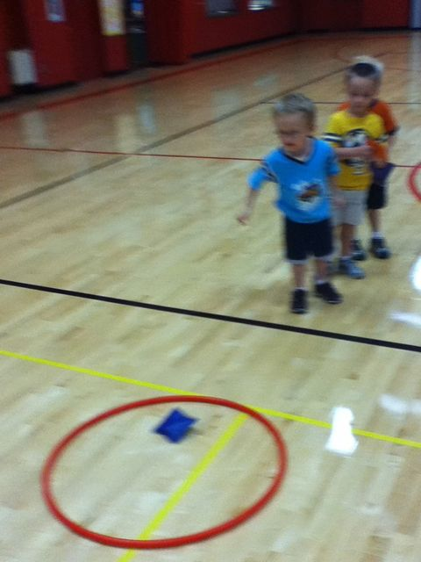
- 3rd + 4th = increase distance between the cone and the target (4 – 6 metres)
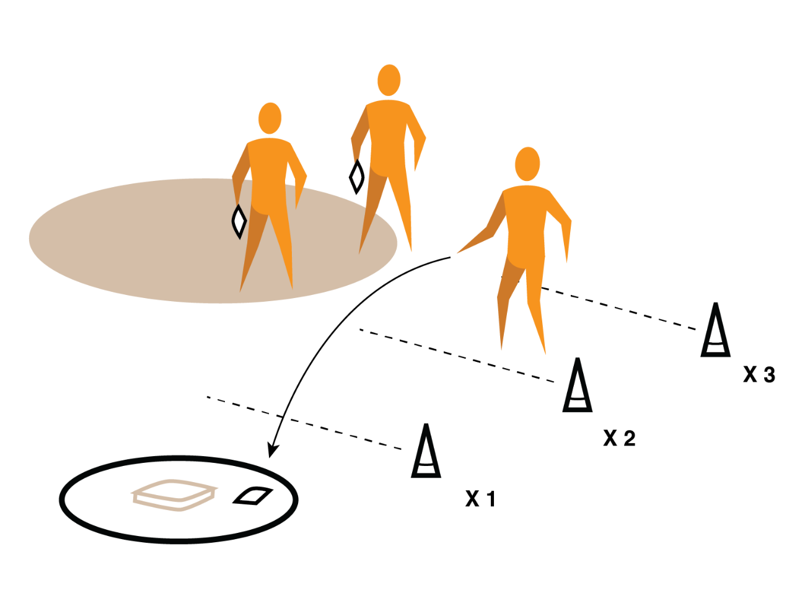
- 5th + 6th = use non dominant hand
