Activity Name: Wall sit

Time : As long as possible

- Stand with your back against a wall, placing your feet about two feet out in front of you. Feet should be hip-distance apart.

- Bending your knees, slide your back down the wall until your knees are at 90 degree angles. Your knee joints should be over your ankle joints, so you may need to inch your feet further from the wall to create proper alignment. Your thighs should remain parallel.

- Hold for as long as possible.

Challenge for each class(How long can you hold it for):
- Junior Infants – 2nd class: Wall sit with hands on the wall
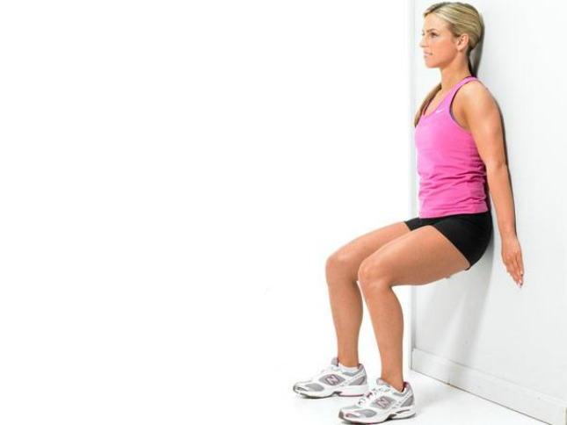
- 3rd + 4th classes: Wall sit with hands out in front of body

- 5th + 6th = Wall sit with hands on your waist and heels off the ground.

